**Ask**

The Questions being asked are:

1. How do annual members and casual riders use Cyclistic bikes differently?
2. Why would casual riders buy Cyclistic annual memberships?
3. How can Cyclistic use digital media to influence casual riders to become members?

**Prepare**

I gathered 12 months’ worth of data from <https://divvy-tripdata.s3.amazonaws.com/index.html>.

All are contained in CSV files. The CSV files contain customer information such as the type of bike they chose, which station they got it from, length of travel, and whether they're a casual or a member.

**Process**

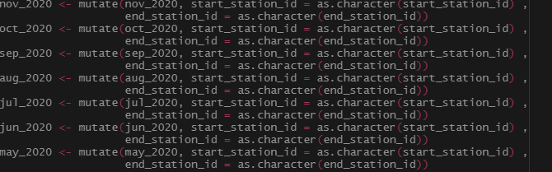

I had to manipulate these seven datasets because there was an error with the data types that prevented them from being merged. I solved it using glimpse() to see where the data type inconsistency was. Then used mutate() to fix the error. Afterwards, the merge was successful.



Next, I deleted the start_lat, start_lng, end_lat, end_lng columns as they’re not useful for the final analysis.

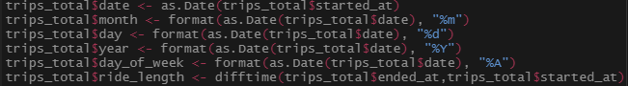

Afterwards, I separated the time columns in to days, months, years to get better insights when we move on to the analysis phase.

**Analyze**

Here, we analyzed the Rider type. The average trip length for the Casual rider was 36 minutes while the Member rider was 15 minutes. Meanwhile, the median tripe length for the Casual rider was 12.6 minutes and the Member was 11.6 minutes. We also compared the number of rides and the average ride length duration in the weekday. We found that while members do ride more throughout the week, the average ride duration is less than the casual members

**Share**

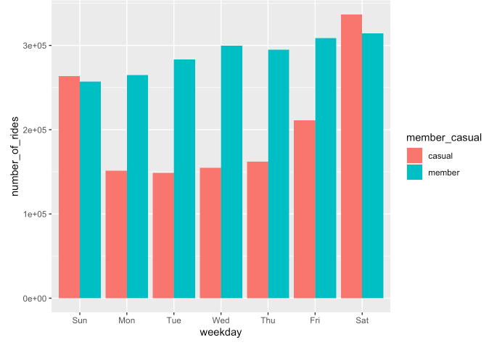

More interestingly, members have a higher number of rides in the weekday compared to casual riders however, it is fairly consistent unlike the casual rider, where they go for more rides in the weekend.

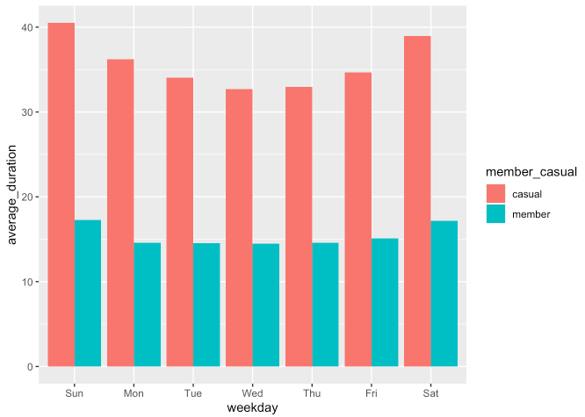

While Casual riders do ride less on the weekdays, they do ride more than your members.

**Act**

So we found out members ride for less time than casual members however they do go for more rides in the weekdays. My hypothesis is most members are using the bike to go to work since it’s probably cheaper for them to buy a monthly membership than to buy a bike. To get our casual members to go for rides on the weekdays, my solution for this is to introduce an incentives program where more rides on the weekdays would mean a cheaper membership price.

Another thing we found was that casual members go out more on the weekend. We can assume that this is for leisure and exploration. The company can implement a competition. Since people like to bike for a long time on the weekend, we can assume they go far. My recommendation is have a picture contest, whoever can snap the best picture of the surrounding area can get a free membership for a few months. This will also force people to get creative and possibly travel more.

One more thing is that Casual riders use ride longer on the weekdays. If that’s the case, maybe have a weekday member package at a discounted price so the casual riders will be more willing to use sign up.